LUBRICATION

The REED concrete pump is equipped with several components that require frequent lubrication. These areas involve the S-Tube shifting mechanism, swing components, the shift and outlet bearings and agitator. To insure the economical service and the long life of these components, grease fittings are installed at each point.

Rapid wear and possible shutdown will result if the unit is operated with inadequate lubrication. Follow the recommendations stated herein, and if needed increase the application of lubricants above these recommendations when the equipment is subject to heavy usage.

MINIMUM LUBRICATING INTERVALS
Recommended lubrication intervals are based on normal use under normal conditions. The lubrication interval must be increased to meet more challenging uses and uses which subject the equipment to high and/or unusual concentration of forces. The lubrication interval must be increased if the pump has been exposed to environmental conditions such as low humidity, high humidity, excessive dust, high temperatures, low temperatures, heavy rainfall, long term storage, ocean air, etc…
1) every hour of operation
2) after completion of every job
All lubrication points must be greased on each and every interval as recommended.

TYPE OF LUBRICANT
Use General Purpose Grease, Shell Alvania EPLFH2, or equivalent if this lubricant is unavailable in your area.

LUBRICATION POINTS
The following graphics are for REFERENCE ONLY.

S-TUBE SHIFT LUBRICATION
ΙΦ ΕΘΥΙΠΠΕΔ ΩΙΤΗ ΔΥΑΛ (2) ΗΨΔΡΑΥΛΙΧ ΣΗΙΦΤ ΧΨΛΙΝΔΕΡΣ,
ΡΕΛΙΕςΕ ΣΗΙΦΤ ΧΙΡΧΥΙΤ ΗΨΔΡΑΥΛΙΧ ΠΡΕΣΣΥΡΕ ΤΟ ΠΡΟΠΕΡΛΨ ΓΡΕΑΣΕ
ΗΨΔΡΑΥΛΙΧ ΣΗΙΦΤ ΧΨΛΙΝΔΕΡΣ ΑΝΔ ΒΕΛΛ ΧΡΑΝΚ

S-TUBE BEARING
GREASE POINTS
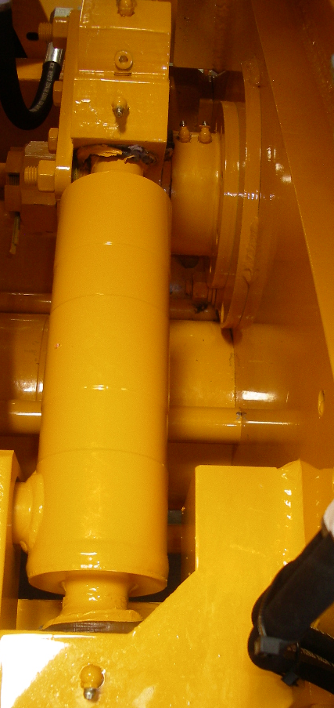

BELL CRANK AND SHIFT CYLINDER
GREASE POINTS

NOTE: RELIEVE S-TUBE CIRCUIT
PRESSURE BEFORE APPLYING
GREASE IF EQUIPPED WITH DUAL (2)
SHIFT CYLINDERS

S-TUBE OUTLET LUBRICATION

Σ−ΤΥΒΕ ΟΥΤΛΕΤ ΓΡΕΑΣΕ ΠΟΙΝΤΣ

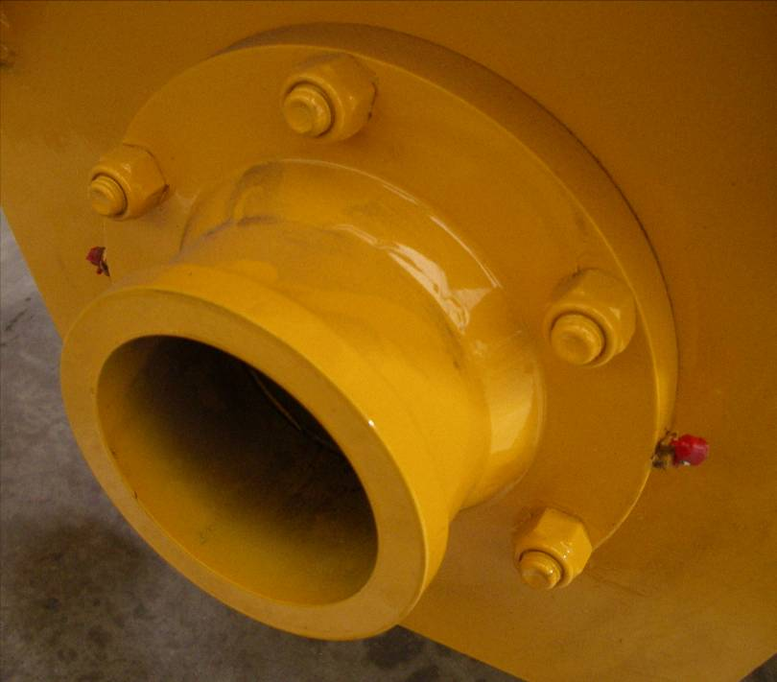
AGITATOR LUBRICATION

HYDRAULIC MOTOR SIDE
GREASE POINT

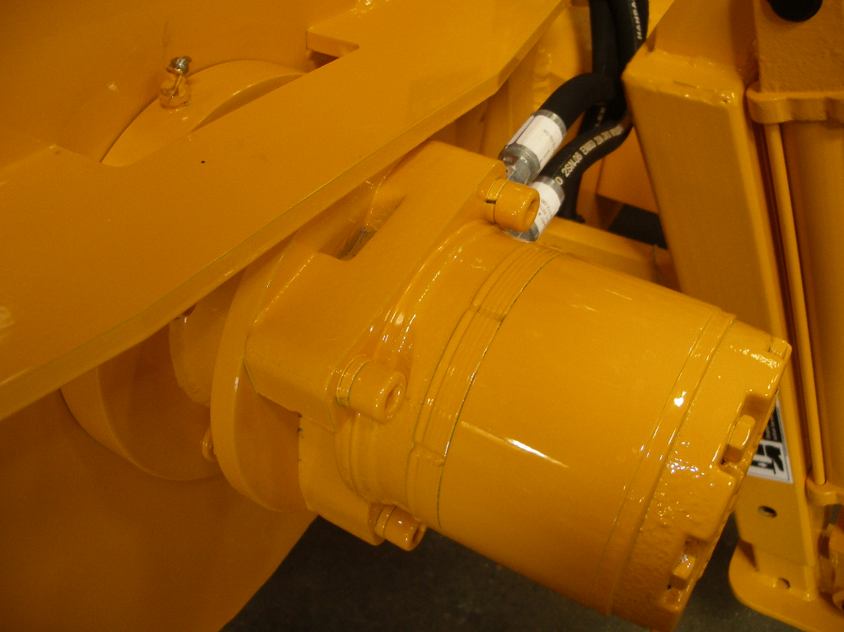

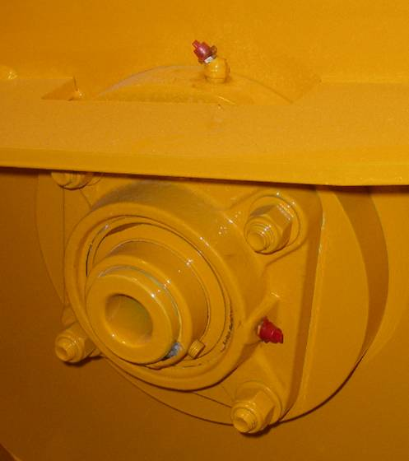

NON-HYDRAULIC MOTOR SIDE
GREASE POINTS

